St Patrick’s Primary School

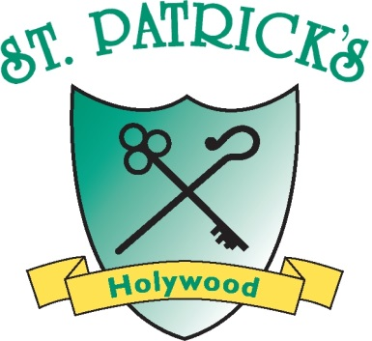

DRAFT
Social Networking Policy

Introduction
Social Networking activities conducted online outside work, such as blogging, involvement in social networking sites such as Facebook, Twitter, Instagram, Wikipedia,Youtube or any similar sites and posting material, images or comments on sites such as You Tube can have a negative effect on an organisation's reputation or image. As Social Media is an ever expanding and changing medium it must be noted that this policy applies to all future as well as existing media. In addition, St. Patrick’s Primary School has a firm commitment to safeguarding children in all aspects of its work. This policy has been written to set out the key principles and code of conduct that we expect of all members of staff with respect to their responsibilities in connection with the use of social networking sites.
Key Principles
- Everyone at St. Patrick’s PS has a responsibility to ensure that they protect the reputation of the school, and to treat colleagues and members of the school with professionalism and respect.
- It is important to protect everyone at St. Patrick’s PS from allegations and misinterpretations which can arise from the use of social networking sites.
- Safeguarding children is a key responsibility of all members of staff and it is essential that everyone at St. Patrick’s PS considers this and acts responsibly if they are using social networking sites out of school. Anyone working in the school either as a paid or voluntary employee or as a subcontractor or non-employed service provider must not communicate with St. Patrick’s PS pupils via social networking and must not accept or initiate Facebook friend requests from students who are enrolled at St. Patrick’s PS on Facebook or other social networking sites
- This policy relates to social networking outside work. Blogging and accessing social networking sites at work using school equipment is not permitted unless it is being used by designated staff for school publicity or promotion after consideration and permission granted by the Principal.
Aims
- To set out the key principles and code of conduct expected of all members of staff, including voluntary/unpaid employees, Governors, and visitors at St. Patrick’s PS with respect to social networking.
- To further safeguard and protect children and staff.
Code of Conduct for Children, Employees including unpaid/voluntary employees, Subcontractor and Governors at St. Patrick’s PS
The following are not considered acceptable at St. Patrick’s PS:
- The use of the school's name, logo, or any other published material without written prior permission from the Principal. This applies to any published material including the internet or written documentation.
- The posting of any communications or images which links the school to any form of illegal conduct or which may damage the reputation of the school. This includes defamatory comments.
- The disclosure of confidential or business-sensitive information; or the disclosure of information or images that could compromise the security of the school, its staff and/or its pupils.
In addition to the above, Children, Employees, including unpaid/voluntary employees, Subcontractor and Governors at St. Patrick’s PS must ensure that:
- They do not make any derogatory, defamatory, rude, threatening or inappropriate comments about the school, or anyone at or connected with the school.
- They use social networking sites responsibly and ensure that neither their personal/professional reputation, nor the school's reputation is compromised by inappropriate postings.
- They are aware of the potential of on-line identity fraud and to be cautious when giving out personal information about themselves which may compromise their personal safety and security.
- While using social media they do not identify themselves as employees or providers/contractors to the school.
- They do not represent their personal views as those of St Patrick’s PS.
- All communications are to be transparent and open to scrutiny.
- Personal contact details of staff including email, home or mobile telephone numbers should not be given unless the need to do so is agreed by the Principal.
- Personal social networking sites are set to Private and current pupils are never listed as approved contacts.
- They never use or access social networking sites of current pupils.
- Text messaging should only be used as part of an agreed protocol and when other forms of communication are not possible.
In addition:
It is strongly recommended that Facebook friend requests not be initiated to or accepted from parents.

Potential and Actual Breaches of the Code of Conduct
In instances where there has been a breach of the above Code of Conduct, the following will apply:
- Any breaches of this policy will be fully investigated. Where it is found that there has been a breach of policy this may result in action being taken under the Disciplinary Procedure. A breach of this policy will be considered to be a serious disciplinary offence which is also contrary to the school's ethos and principles.
- The Board of Governors will take appropriate action in order to protect the school's reputation and that of its staff, Governors and children.

